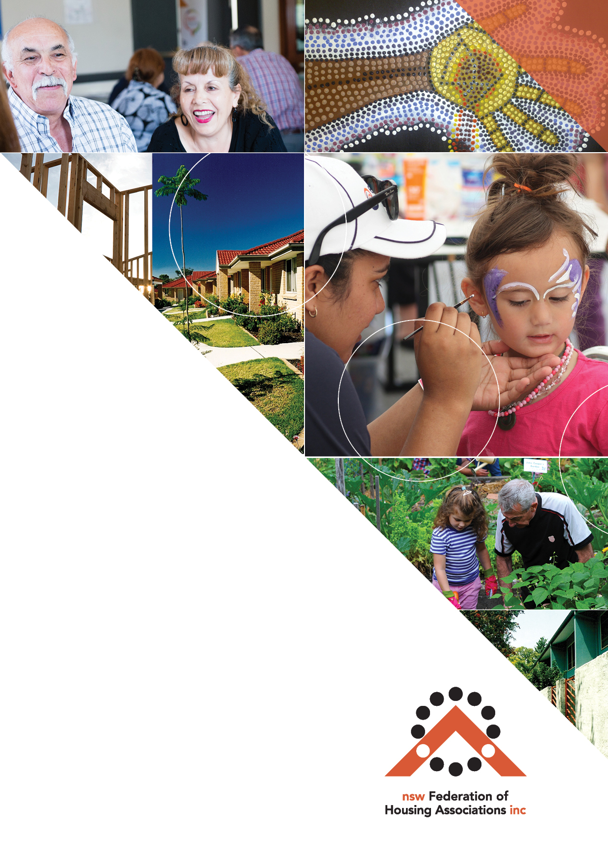

**TOOL**

About Affordable Housing

About Affordable Housing

When is housing ‘affordable’?

Housing is generally considered to be **‘affordable’** when very low, low and moderate income households can pay their rent or mortgage and still have enough left over to pay for other basic needs such as food, clothing, transport, medical care and education.

Housing costs will generally be less than 30% of household income to be affordable.

#### Hospital cleaner, Trang, what a difference Community Housing makes

Trang is 28 years old, and arrived from Vietnam 5 years ago. Trang felt lucky to get a full-time job as a cleaner at the RPA Hospital in Camperdown where she earns $750 p.w. Since her relationship broke down 2 years ago, she has been living between friends’ places while she’s been trying to find an affordable place to rent. A colleague suggested she contact her local community housing provider. Trang made the call and a few months she was moving into a studio apartment right near the hospital. Best of all, her rent was affordable on her cleaner’s wage. It gave her the freedom to save a bit and think about what she wanted to do next with her life.

What are some examples of Affordable Housing?

Affordable housing includes a wide range of products. As well as public and community housing, this can include affordable ‘key worker’ rental housing, and share equity purchase products. Smaller apartments and secondary dwelling in some areas can also be affordable.

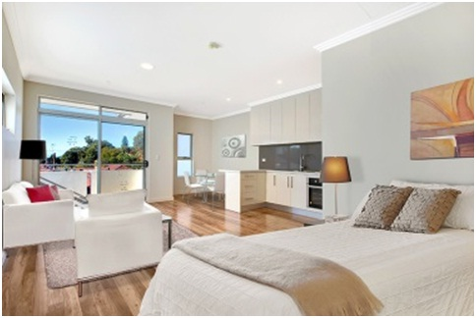

‘New Generation’ Boarding Houses, like the inner-west boarding house managed by Hume Community Housing can also be an affordable option for very low income single people and couples, especially when managed by a community housing provider.

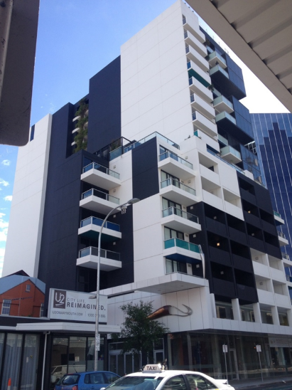

Modern affordable housing developments are well designed, of very high quality, and look the same as nearby developments. An example is UNO in inner-city Adelaide, with 146 apartments for social housing tenants, key worker renters, and families who have purchased their units at discount and full market prices.

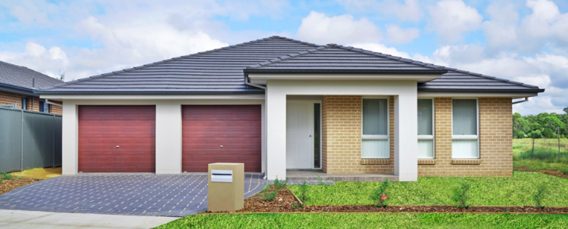Urban release areas like Ropes Crossing in Sydney’s west include affordable rental homes designed to the same high standards as their private market neighbours. Homes managed by Wentworth Community Housing are often rented to low and moderate income families working in Parramatta of other major service centres.

Research shows that including affordable housing will not have a negative impact on property prices, and will often have a positive effect due to urban improvements.

Why is Affordable Housing Important?

**Anyone** **in the community could need affordable housing**. This includes a young person who wants to live near where they grew up, a recently divorced person, working families with one or even two low incomes, or an older person on a reduced retirement income.

Lack of affordably priced housing not only affects the quality of life of families. The loss of young families and workers in lower paid essential service jobs can adversely affect local economies, and is contributing to labour shortages in Sydney and more expensive regions.

#### Key Worker & Private Renter in Randwick, Carleen, without Affordable Housing

Carleen is 38 years old Registered Nurse at St Vincent’s Hospital in Darlinghurst, earning an award wage of $1,200 per week, making her a ‘Low Income’ worker. She is a shift worker and can’t live too far from where she works. She doesn’t own a car, so Randwick is an ideal location for public transport, even when her shifts end very late. But the rent on Carleen’s one-bedroom unit takes more than 40% of her income, and she has just received notice of a rent increase to $525 per week. With other expenses, it’s been difficult to save toward a deposit to buy her own unit. Carleen is worried that if rents keep increasing, she’ll have to look for a place further out, making shift work very difficult.

For others, affordable housing means just keeping a roof over their head.

#### Long-term Kirribilli boarding house lodger, Margaret, can stay in her community

Margaret is 65 years old. She has been living in a small, single room in an old, rambling 99 room boarding house in Kirribilli since the early-1990s, which she rarely leaves. Margaret has chronic mental illness and gets by on the Disability Support Pension. She has always been able to pay her rent. The boarding house is now being redeveloped into luxury apartments with views of Sydney Harbour. There is nowhere locally, or in wider Sydney, where Margret can afford to rent privately. Luckily, she has been allocated priority housing by Link Housing in an apartment jointly developed by Link and North Sydney Council. Without this, she would most likely be homeless.

Where can I find out more?

**[Insert CHP name]** has been providing affordable housing in your community for **[?]** years. If you want to know more about affordable housing, or think you or someone you know might be eligible, contact us on **[insert contact details].**